REQUEST FOR PROPOSAL (RFP)
HABITAT RESTORATION AT THE BOQUERON STATE FOREST

The Department of Natural and Environmental Resources through the Natural Protected Areas Bureau is seeking applicants to develop and implement habitat restoration projects to restore degraded wetland ecosystems within the Boquerón State Forest (BEF).
The Boqueron State Forest (BSF) comprises a total of 4,629 acres among the municipalities of Lajas, Cabo Rojo and Mayaguez at the southwest part of Puerto Rico. Within the BSF, three areas were identified to have the potential to serve as important habitat for aquatic birds. Those are: Pitahaya, Playa Sucia and Joyuda Lagoon. Both Pitahaya and the Joyuda Lagoon were severely affected by Hurricane Maria. Significant amount of debris accumulated reducing hydrology connection with the wetlands, which resulted in vegetation mortality. In the other hand, Playa Sucia had suffered through the years a significant degradation due mainly to human impact causing vegetation mortality, changes in water quality as well as a reduction on species richness and abundance.

The Project, had the following objectives: (1) Conduct a study to assess the current hydrological conditions of Pitahaya, Playa Sucia and Joyuda Lagoon, and (2) Implement strategies to restore connectivity in these areas in order to provide suitable habitat for aquatic birds.

Special consideration will be given to the following types of projects:
- Those that specify how the project will help to determine key hydrological and ecological variables that will inform concurrent restoration efforts
- Those that can provide evidence of experience in large-scale wetland or ecosystem enhancement efforts
- Those that consider historical hydrological conditions in a degraded landscape
- Those that emphasize stakeholders and community involvement.

Tasks:
- Must comply with federal and commonwealth laws and regulatory as applicable like: Puerto Rico Environmental Public Policy Law, National Environmental Policy Act (NEPA), Regulation 4860, Regulation for the Management of Vulnerable and Endangered Species in the Commonwealth of Puerto Rico, among other.
- Develop a work plan in junction with DNER personnel.
- Planning, design, request permits and implement the habitat restoration project.
- Submit quarterly progress reports and with each invoice.
- Coordinate the development of a Hydraulic-Hydrologic study for selected sites (Phase 1)
- Develop an implantation plan based on the H-H Study (Phase 2)
- Hire a biologist/ecologist that will oversee field operations of Phase 2
- Coordinate any and all restoration actions with DNER personnel and interested stakeholders
- Submit a final report summarizing the following:
  - Methodology used to design and implement the project
  - Data summary and findings (if applicable)
  - Lessons learned over the course of the project
  - Recommendations for future or follow-up work
Proposal content: The proposal should not exceed 10 pages in length. Pages in excess of 10 will not be reviewed. The proposal should address the following items in a concise and yet complete manner and offer all the necessary information for the evaluation the proposal:
- Title page.
    - Project title
    - Project locations(s)
    - Project team/Project team organization – include name, title, affiliations and contact information of the project leader and key personnel.
    - Project Cost- including deliverables (progress report, etc)
    - Abstract- describe briefly the project being proposed, and any important details.
- Proposal Narrative:
    - Goals and Objectives
    - Methodology- outline project design and describe tasks that will be completed to meet the project objectives
    - Site description- provide a description of the site selected and justification for choosing this site. Include map(s) of the project area(s) and site photographs.
    - Roles and Responsibilities- define the roles and responsibilities of all project participants
    - Relevant Experience-briefly describe relevant experience of the project leader and partners.
    - Outputs, Outcomes, and Evaluation- specify the expected products and results that will be produced over the course of the project. Discuss the methods to evaluate the effectiveness and success of the project.
    - Project Schedule - dates of starting and finishing project, as well as a detailed time frame regarding reports, milestones and/or specific activities.
    - Project Budget – matching funds are encouraged, but not required.

Target areas: Proposed projects should be located within the geographical context of the Boqueron State Forest
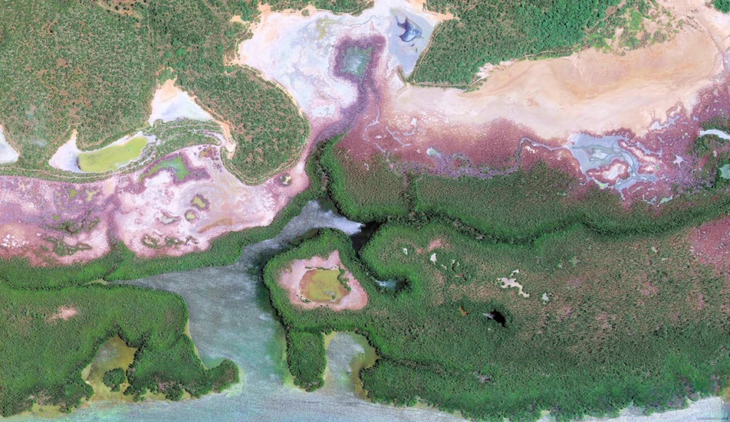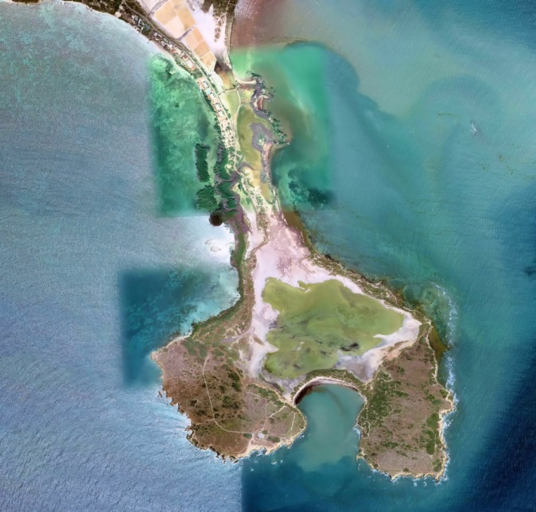
La Pitahaya Playa Sucia

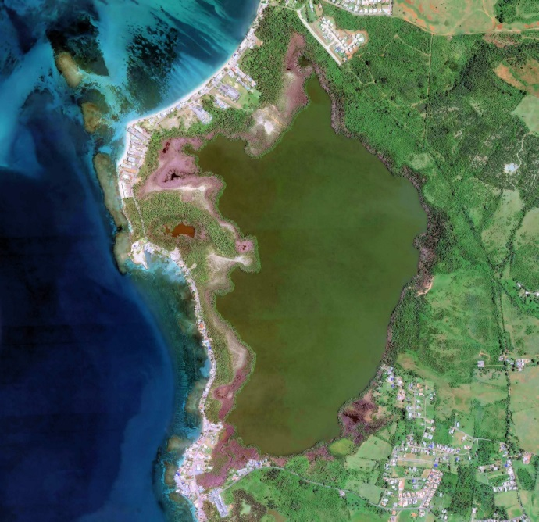
Joyuda Lagoon

Eligibility: All entities authorized to work in Puerto Rico
Available funding: $850.,000.00 This EWN will be implemented in two phases: 1) planning, design and permitting process; and 2) EWN project construction.
Estimated Timeframe: October 2021 through June 2024
Submittal: All proposals must be received by 4:00pm EST on Thrurday September 30th, 2021.
Applicants should submit both an electronic and hardcopy of their proposal as follows:
- Digital- pdf or Microsoft Word documents. Could be sent at dlopezocasio@drna.pr.gov
- Hard copy- Two hardcopies should be delivered to:
Darien López
Department of Natural and Environmental Resources
Natural Protected Areas and Forestry Bureau
Edificio Cruz A. Matos
Carr. 8838 km 6.3 El Cinco
Río Piedras, PR 00936

Proposal Evaluation Process: Proposals that meet all the requirements of this RFP, will be evaluated by a review team of the NPAFSB. Proposals will be evaluated on the applicant’s demonstrated ability to perform the tasks previously described. Evaluating the effectiveness of the proposed practices and partners involved will also weigh heavily. The criteria that will be used to evaluate the Proposals will be:
    - Comprehensiveness of the proposal.
    - Individual or firm’s experience and history of performance on similar projects, regarding such factors as quality of work, cost control, and ability to meet schedule.
    - Adequacy of technical staff, as demonstrated by experience, education, and potential project role.
    - Firm or individual understands of the services required by the NPAFSB.
    - Proposed costs.
    - Organization and scheduling of the project requirements.
    - Knowledge and ability to comply with federal procurement standards and grant regulations.
    - Professional quality of the Project Proposal: conciseness, clarity, and thoroughness of presentation.
    - Project manager accessibility.
    - Ability to complete project in a short period of time.

CRITERIA | EVALUATED ITEMS | SCORE
Working Plan | Ability to perform the required works, a  comprehensive work plan, including detailed itinerary. | 55
Compliance | Regarding compliance with state regulations (license or certifications to practice your profession in Puerto Rico) and applicable federal detailed content | 10
Experience | Previous experience | 20
Budget justification | Offer Amount proposed. Proposals whose budget exceeds $ 850,000.00 will not be accepted | 15

Consultant Selection Notification: DNER-Natural Protected Areas and Forestry Service Bureau (NPAFSB) will notify the selection of the consultant not later than April 30, 2021.
Other Special Conditions:
- This RFP does not commit the NPASFSB to award a contract, to defray any costs incurred in the preparation of a Proposal pursuant to this RFP, or to procure or contract for work.
- All Proposals submitted in response to this RFP will become property of the NPAFSB and will be public records, and as such they may be subjected to public review.
- The NPAFS, at its sole discretion, reserves the right to cancel this RFP for any or no reason, in part or in its entirety, including but not limited to: selection schedule, submittal date, and submittal requirements. If the NPASF cancels or revises the RFP, all potential Contractors will received notification letter advising the cancelation or revision of the RFP.
- The NPAFSB reserves the right to request additional information and/or clarifications from any or all potential Contractors participating in this RFP.
- Announcement of the selected contractor, contract awards, and all data provided by the NPAFSB shall be protected from public disclosure. Consultants desiring to release information to the public must receive prior written approval from the NPASFB. The NPAFSB, at its sole discretion, shall determine the release and disclosure of information related to this RFP and any final work products as a result of this.
- It will be required that, the selected Contractor signs a contract for Professional Services.

