REQUEST FOR PROPOSAL (RFP)
HABITAT RESTORATION AT THE NORTHEAST ECOLOGICAL CORRIDOR NATURAL RESERVE

The Department of Natural and Environmental Resources through the Natural Protected Areas Bureau is seeking applicants to develop and implement habitat restoration projects to restore degraded wetland ecosystems within the Northeast Ecological Corridor Natural Reserve (NECNR).

The Northeast Ecological Corridor is a coastal reserve that consists of 3,000 acres between Luquillo and Fajardo. Land-use practices over the last 100 years have transformed this landscape into a mosaic of ecosystems that range from primary coastal dry forests to drained wetlands and other degraded ecosystems. The most important factors currently affecting these ecosystems are hydrological modifications that are a legacy of sugar cane agriculture and the invasive species that dominate these degraded landscapes.

The project has the following objectives: 1) Conduct a study the asses the current hydrological conditions of the reserve, and 2) implement strategies to restore hydrological connectivity in selected areas to improve habitat condition and biodiversity.

Special consideration will be given to the following types of projects:
- Those that specify how the project will help to determine key hydrological and ecological variables that will inform concurrent wetland restoration efforts
- Those that can provide evidence of experience in large-scale wetland or ecosystem enhancement efforts
- Those that can research and consider historical hydrological conditions in a degraded coastal landscape
- Those that emphasize stakeholders and community involvement.

Tasks:
- Must comply with federal and commonwealth laws and regulatory as applicable like: Puerto Rico Environmental Public Policy Law, National Environmental Policy Act (NEPA), Regulation 4860, Regulation for the Management of Vulnerable and Endangered Species in the Commonwealth of Puerto Rico, among other.
- Develop a workplan in junction with DNER personnel.
- Planning, design, request permits and implement the habitat restoration project.
- Submit quarterly progress reports and with each invoice.
- Coordinate the development of a Hydraulic-Hydrologic study for the 3,000 acres of the Natural Reserve (Phase 1)
- Develop a plan for the implantation phase based on the H-H Study (Phase 2)
- Hire a biologist/ecologist that will oversee field operations of Phase 2
- Coordinate any and all restoration actions with DNER personnel and interested stakeholders
- Submit a final report summarizing the following:
  - Methodology used to design and implement the project
  - Data summary and findings
  - Lessons learned over the course of the project
  - Recommendations for future or follow-up work
Proposal content: The proposal should not exceed 10 pages in length. Pages in excess of 10 will not be reviewed. The proposal should address the following items in a concise and yet complete manner and offer all the necessary information for the evaluation the proposal:
- Title page.
    - Project title
    - Project locations(s)
    - Project team/Project team organization – include name, title, affiliations and contact information of the project leader and key personnel.
    - Project Cost- including deliverables (progress report, etc)
    - Abstract- describe briefly the project being proposed, and any important details.
- Proposal Narrative:
    - Goals and Objectives
    - Methodology- outline project design and describe tasks that will be completed to meet the project objectives
    - Site description- provide a description of the site selected and justification for choosing this site. Include map(s) of the project area(s) and site photographs.
    - Roles and Responsibilities- define the roles and responsibilities of all project participants
    - Relevant Experience-briefly describe relevant experience of the project leader and partners.
    - Outputs, Outcomes, and Evaluation- specify the expected products and results that will be produced over the course of the project. Discuss the methods to evaluate the effectiveness and success of the project.
    - Project Schedule - dates of starting and finishing project, as well as a detailed time frame regarding reports, milestones and/or specific activities.
    - Project Budget – matching funds are encouraged, but not required.

Target areas: Proposed projects should be located within the geographical context of the Northeast Ecological Corridor Natural Reserve
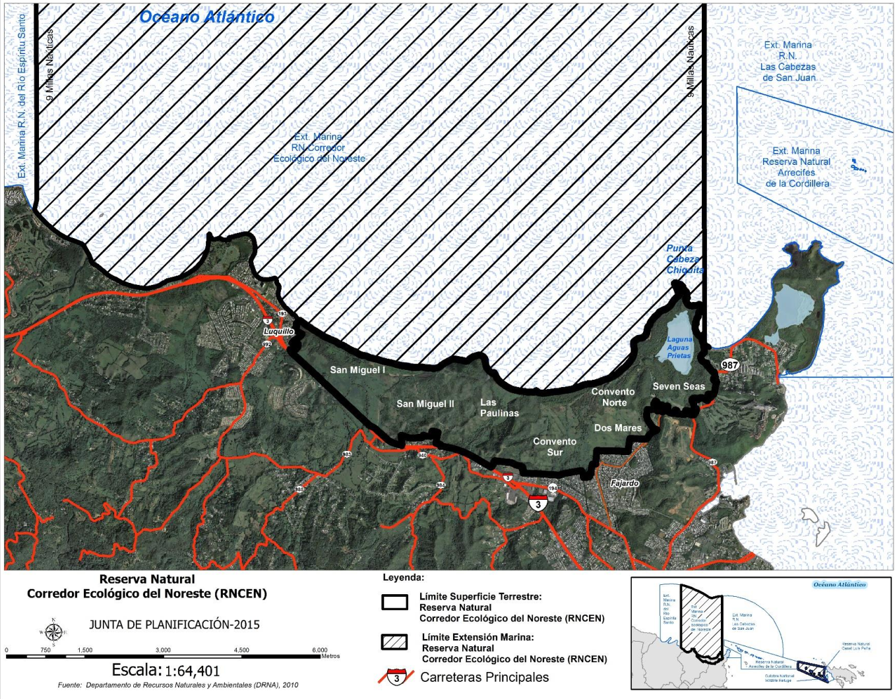
Eligibility: All entities authorized to work in Puerto Rico
Available funding: $675,000. This project will be implemented in two phases: 1) Hydrologic study, planning, design and permitting process, 2) Implementation of ecosystem enhancement and restoration plan
Estimated Timeframe: November 2021 through October 2024
Submittal: All proposals must be received by 4:00pm EST on Friday October 1st 2021.
Applicants should submit both an electronic and hardcopy of their proposal as follows:
- Digital- pdf or Microsoft Word documents. Should be sent at rcolon@drna.pr.gov
- Hard copy- Two hardcopies should be delivered to:
Dr. Ricardo J. Colón-Rivera
Department of Environment and Natural Resources
Bureau of Natural Protected Areas
Edificio Cruz A. Matos
Carr. 8838 km 6.3 El Cinco
Río Piedras, PR 00936
Proposal Evaluation Process: Proposals that meet all the requirements of this RFP, will be evaluated by a review team of the BNPA. Proposals will be evaluated on the applicant’s demonstrated ability to perform the tasks previously described. Evaluating the effectiveness of the proposed practices and partners involved will also weigh heavily. The criteria that will be used to evaluate the Proposals will be:
    - Comprehensiveness of the proposal.
    - Individual or firm’s experience and history of performance on similar projects, regarding such factors as quality of work, cost control, and ability to meet schedule.
    - Adequacy of technical staff, as demonstrated by experience, education, and potential project role.
    - Firm or individual understands of the services required by the DNER.
    - Proposed costs.
    - Organization and scheduling of the project requirements.
    - Knowledge and ability to comply with federal procurement standards and grant regulations.
    - Professional quality of the Project Proposal: conciseness, clarity, and thoroughness of presentation.
    - Project manager accessibility.
    - Ability to complete project in a short period of time.

Consultant Selection Notification: DNER will notify the selection of the consultant not later than October 30, 2021.
Other Special Conditions:
- This RFP does not commit the to award a contract, to defray any costs incurred in the preparation of a Proposal pursuant to this RFP, or to procure or contract for work.
- All Proposals submitted in response to this RFP will become property of the DNER and will be public records, and as such they may be subjected to public review.
- The DNER, at its sole discretion, reserves the right to cancel this RFP for any or no reason, in part or in its entirety, including but not limited to: selection schedule, submittal date, and submittal requirements. If the DNER cancels or revises the RFP, all potential Contractors will received notification letter advising the cancelation or revision of the RFP.
- The DNER reserves the right to request additional information and/or clarifications from any or all potential Contractors participating in this RFP.
- Announcement of the selected contractor, contract awards, and all data provided by the DNER shall be protected from public disclosure. Consultants desiring to release information to the public must receive prior written approval from the DNER. The DNER, at its sole discretion, shall determine the release and disclosure of information related to this RFP and any final work products as a result of this.
- It will be required that, the selected Contractor signs a contract for Professional Services.

